EXPT NO: 1 | BUILDING AND TRAINING A SIMPLE ARTIFICIAL NEURAL NETWORK (ANN) FOR REGRESSION AND CLASSIFICATION
DATE:

PRE-LAB QUESTIONS (PROVIDE BRIEF ANSWERS TO THE FOLLOWING QUESTIONS)

- What is an Artificial Neural Network (ANN)?
An Artificial Neural Network (ANN) is a machine learning model inspired by the human brain. It consists of interconnected neurons that learn patterns from data by adjusting weights, enabling tasks such as prediction, classification, and pattern recognition.

- What are the functions of the input, hidden, and output layers in an ANN?
The input layer receives feature data, the hidden layer processes information and learns patterns using weights and activation functions, and the output layer produces the final prediction or classification based on the learned knowledge.

- Why is feature scaling important before training an ANN?
Feature scaling ensures all input features have similar ranges, preventing large-valued features from dominating training. It speeds up gradient descent, improves convergence, increases model accuracy, and helps the neural network learn efficiently.

- Differentiate between regression and classification problems with examples.
Regression predicts continuous values, such as house prices or temperature. Classification predicts discrete categories, such as spam detection, disease diagnosis, or identifying whether an email is spam or not spam.

- What is the role of the activation function in a neural network?
An activation function introduces non-linearity into a neural network, allowing it to learn complex patterns. It determines whether a neuron should activate and enables the network to solve difficult real-world problems accurately.

AIM
To understand the implementation of Artificial Neural Networks (ANN) using TensorFlow and evaluate their performance on regression and classification problems.

SOFTWARE REQUIREMENTS
- Python 3.x
- Google Colab / Jupyter Notebook
- TensorFlow 2.x
- NumPy
- Pandas
- Matplotlib
- Scikit-learn

LEARNING OBJECTIVES
After completing this experiment, students will be able to:
- Understand the architecture of an Artificial Neural Network.
- Build an ANN for regression problems.
- Build an ANN for classification problems.
- Train and evaluate neural network models.
- Compare different evaluation metrics used for regression and classification.

THEORY
An Artificial Neural Network (ANN) is a machine learning model inspired by the human brain. It consists of interconnected neurons organized into layers.
A simple ANN contains:
- Input Layer
- Hidden Layer(s)
- Output Layer
During training, the ANN learns by updating weights using Backpropagation and an optimization algorithm such as Adam Optimizer.

PART A – ANN FOR REGRESSION
DATASET: California Housing Dataset
SOURCE: Scikit-learn
DESCRIPTION
- Samples: 20,640
- Features: 8
- Target: Median House Value

FEATURES
Feature | Description
MedInc | Median Income
HouseAge | House Age
AveRooms | Average Rooms
AveBedrms | Average Bedrooms
Population | Population
AveOccup | Average Occupancy
Latitude | Latitude
Longitude | Longitude

ALGORITHM
- Import libraries.
- Load California Housing dataset.
- Split into training and testing sets.
- Standardize the features.
- Build ANN model.
- Compile the model.
- Train the model.
- Predict house prices.
- Evaluate using:
  - MSE
  - MAE
  - RMSE

CODE AND OUTPUT:
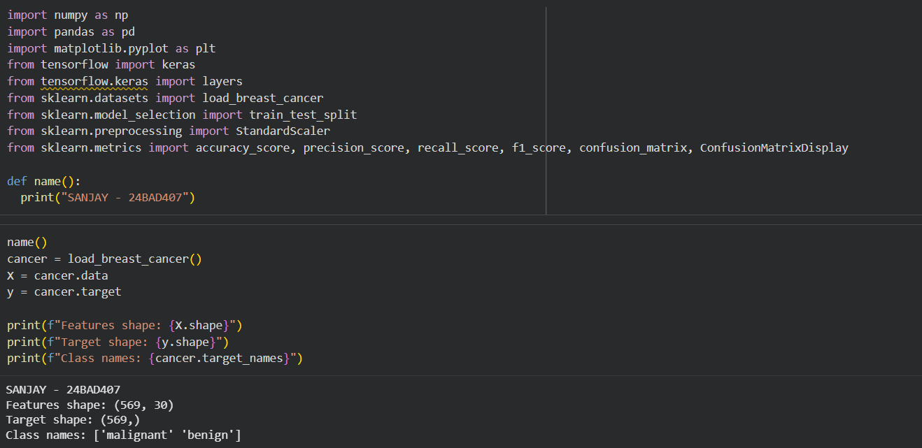
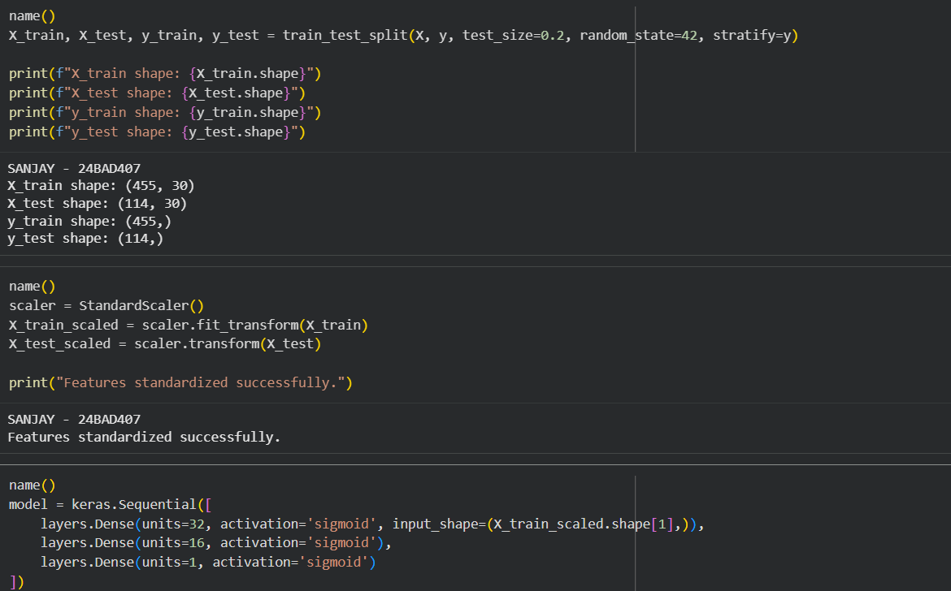
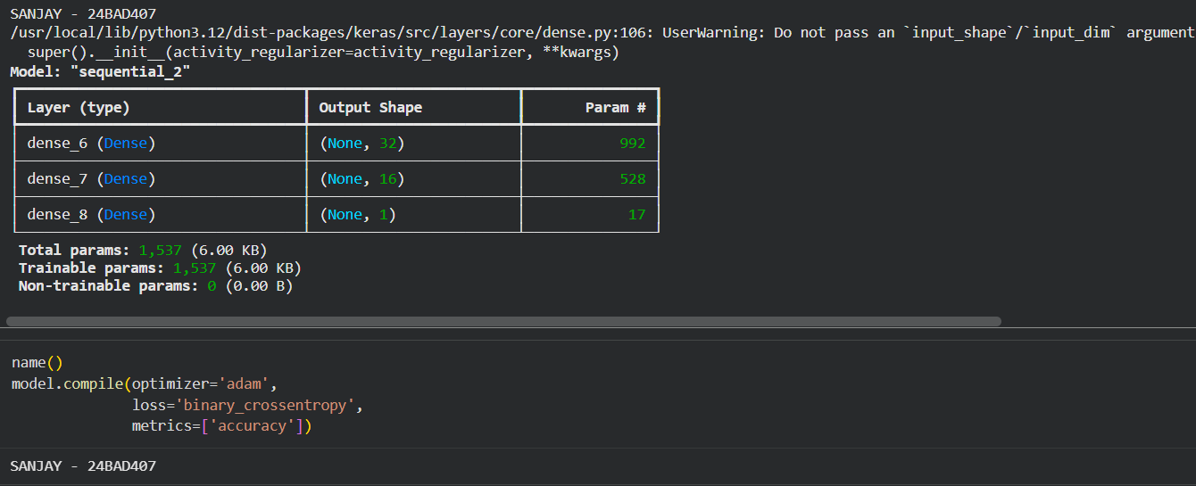
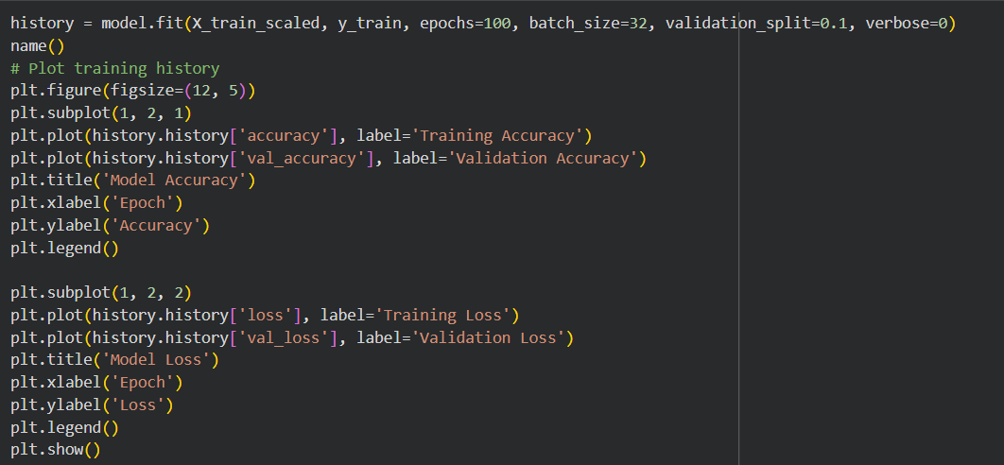
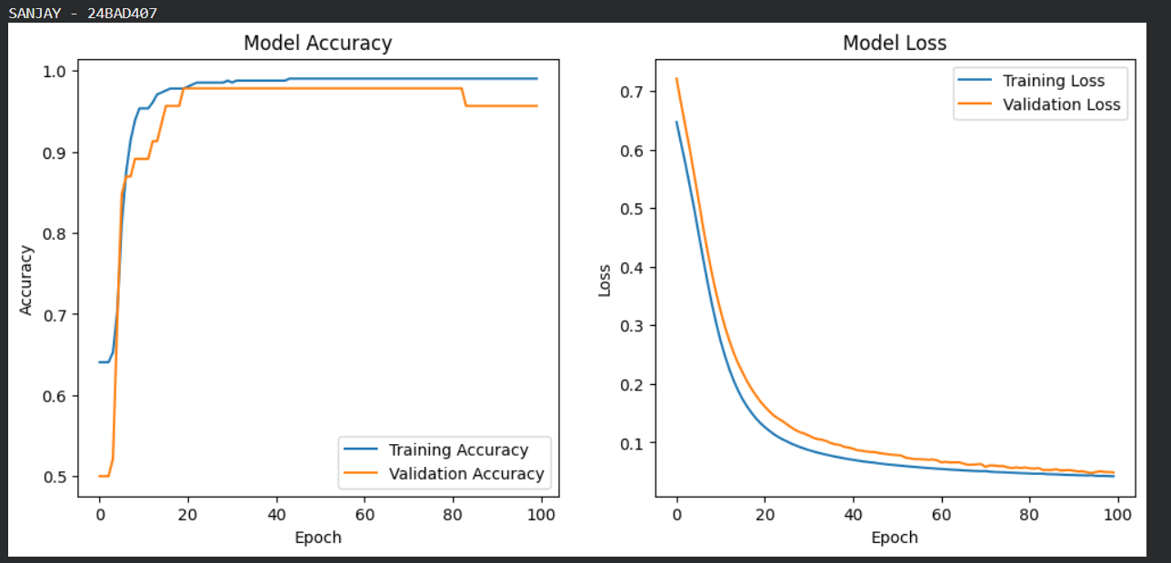
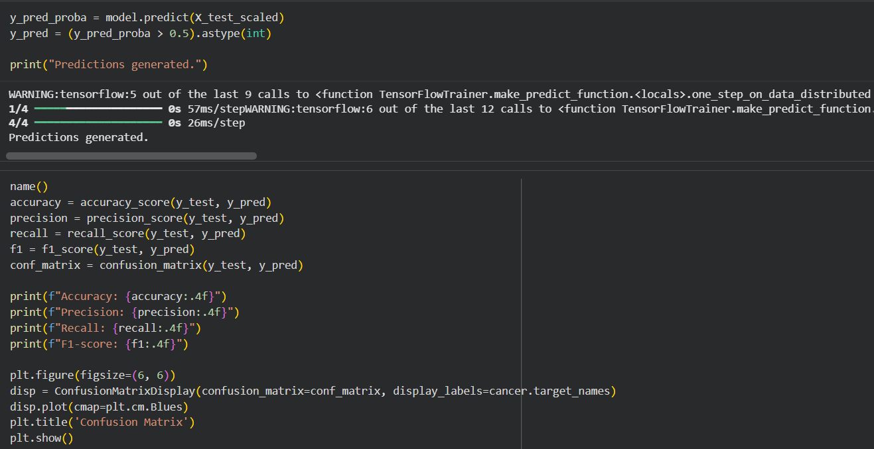

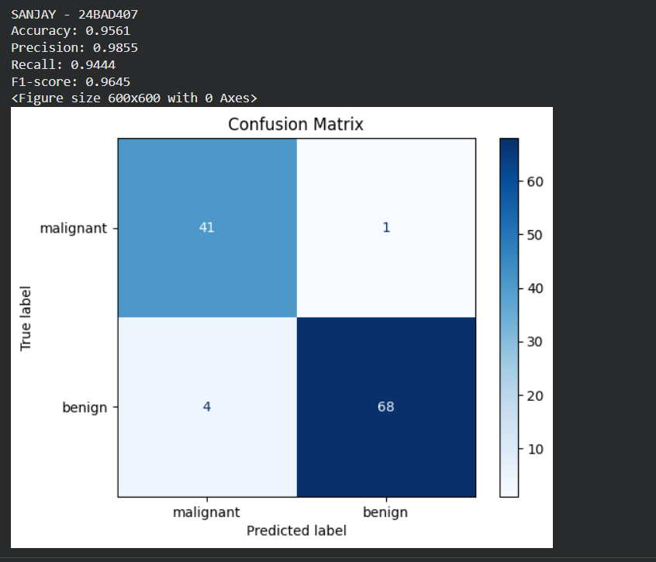

PART B – ANN FOR CLASSIFICATION
DATASET: Breast Cancer Wisconsin Dataset
SOURCE: Scikit-learn
DESCRIPTION
- Samples: 569
- Features: 30
- Classes:
  - Malignant
  - Benign

ALGORITHM
- Import libraries.
- Load Breast Cancer dataset.
- Split dataset.
- Standardize features.
- Design ANN.
- Compile model.
- Train model.
- Predict labels.
- Evaluate:
  - Accuracy
  - Precision
  - Recall
  - F1-score
  - Confusion Matrix

CODE & OUTPUT :
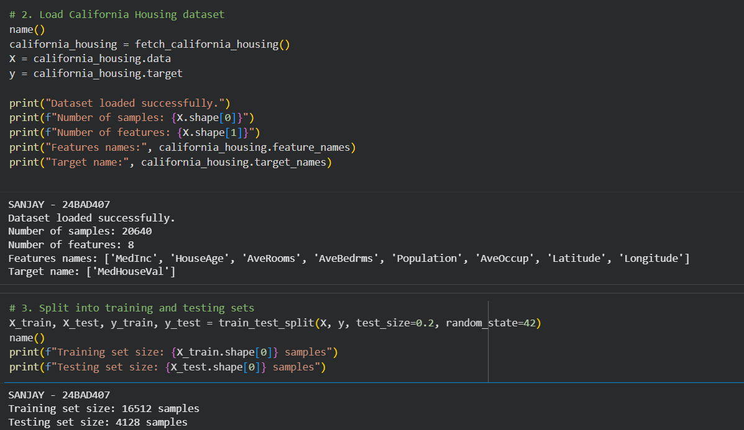
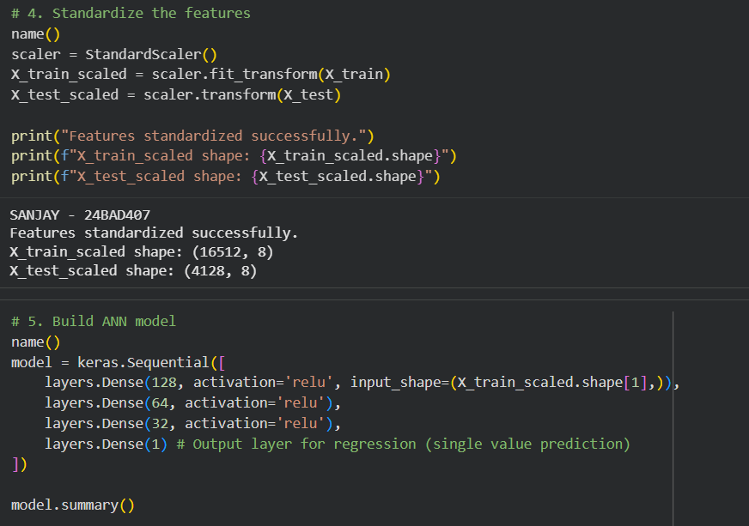
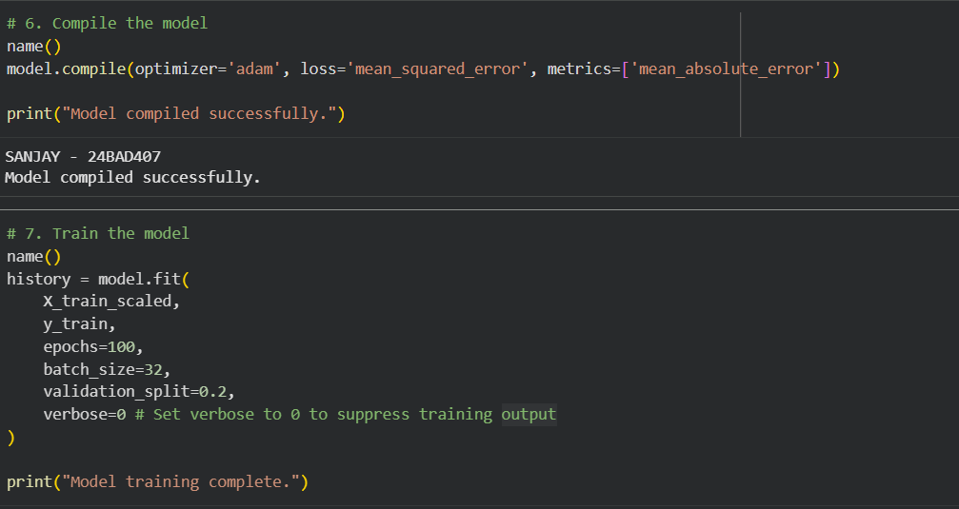
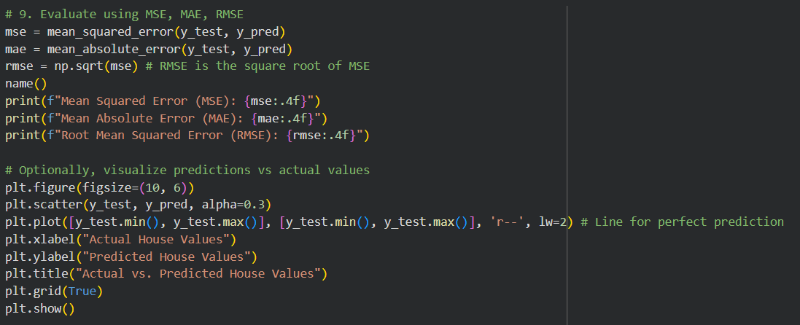
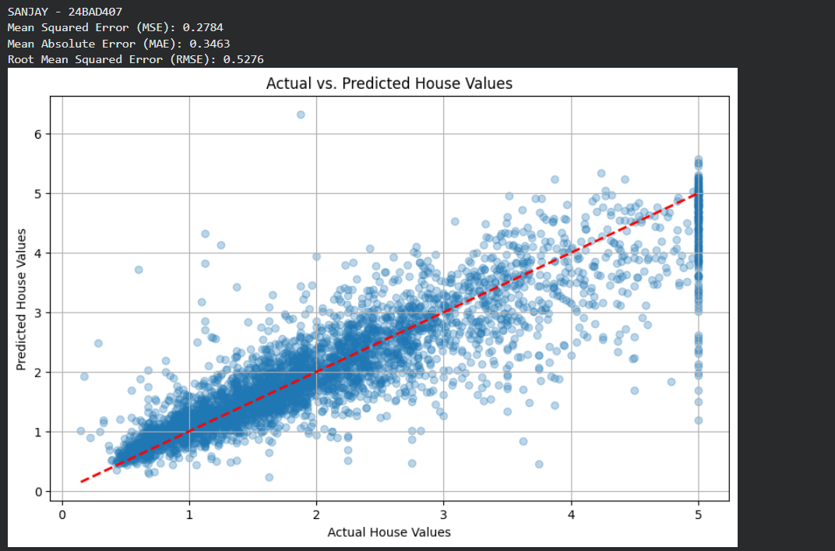

POST-LAB QUESTIONS (PROVIDE BRIEF ANSWERS TO THE FOLLOWING QUESTIONS)

- Why is the Adam optimizer commonly used in ANN training?
Adam optimizer combines momentum and adaptive learning rates, enabling faster convergence, stable training, efficient optimization, and better performance across datasets.

- Compare Mean Squared Error (MSE) and Mean Absolute Error (MAE). Which metric is more sensitive to outliers?
MSE squares errors, heavily penalizing large deviations, while MAE uses absolute errors. Therefore, MSE is more sensitive to outliers.

- Why is the sigmoid activation function used in binary classification?
Sigmoid converts outputs into probabilities between 0 and 1, making it ideal for binary classification by enabling threshold-based predictions.

- How does increasing the number of hidden layers affect the performance of an ANN?
More hidden layers improve learning of complex patterns but increase computational cost, training time, and risk of overfitting without regularization.

- Compare the evaluation metrics used for regression and classification tasks. Why are different metrics required for these problems?
Regression uses MSE, MAE, RMSE, while classification uses accuracy, precision, recall, F1-score. Different outputs require task-specific performance evaluation metrics.

ASSESSMENT
Description | Max Marks | Marks Awarded
Pre Lab Exercise | 5
In Lab Exercise | 10
Post Lab Exercise | 5
Viva | 10
Total | 30
Faculty Signature

